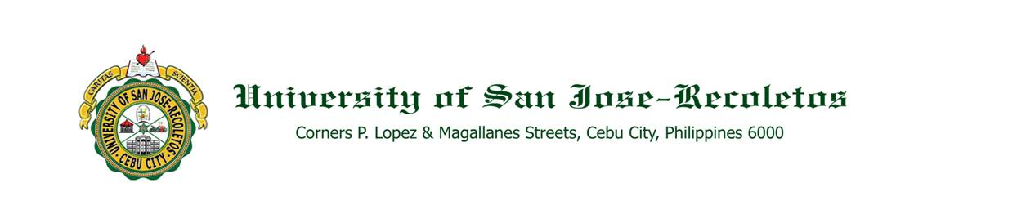

**OFFICE OF THE PRESIDENT**

**TO : ALL CONCERNED August 7, 2020**

**SUBJECT : A P P O I N T M E N T S**

Greetings!

The School Board is pleased to inform you of the approval of the appointments of the lay administrators for Academic Year 2020-2021. Attached is the list of the appointments for your reference.

Please extend to them you usual kind support and cooperation so that they can effectively carry out their tasks, duties and responsibilities.

Thank you and God bless. Adelante!

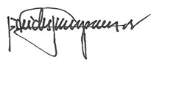

REV. FR. CRISTOPHER C. MASPARA, OAR

President

/bvs

Attachment